 

ASSIGNMENT ON INTERNET TECHNOLOGY(IT)

Assignment Weightage & Type

60% Portfolio Coursework

Corse: BSc (Hons) CS & DF (Sem_2)

**NAME: AMAN YADAV**

**STUDENT ID: 10722**

**WEEK 7**

**EXERCISE 1**

Create a new web page and create a Form with following form controls.

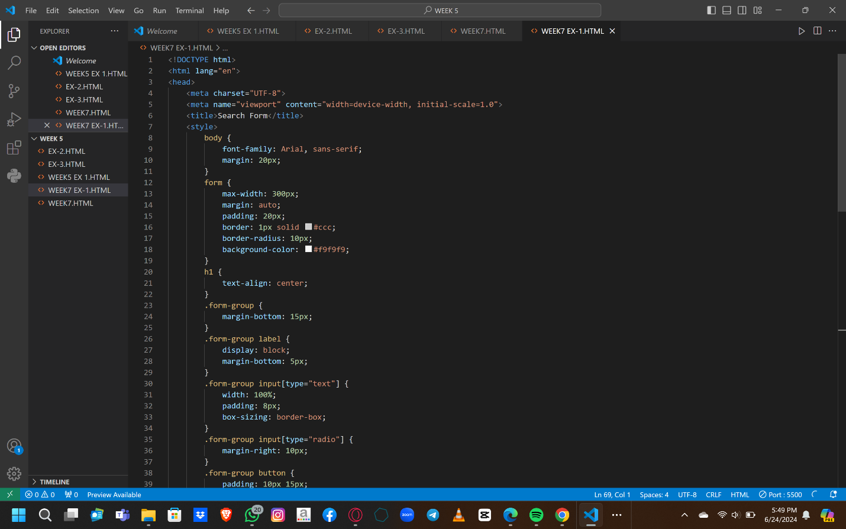

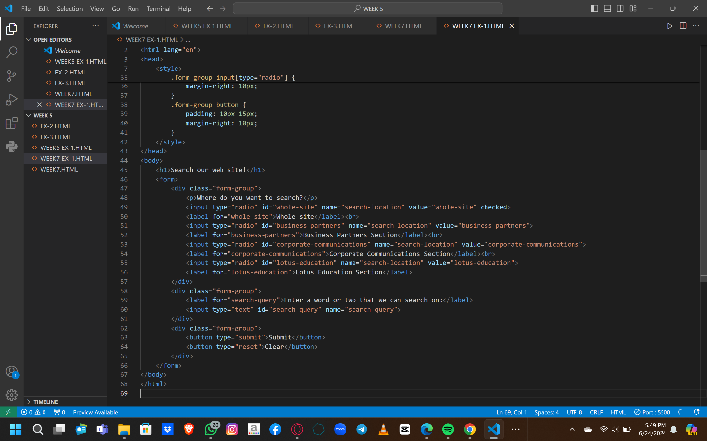

**OUTPUT:**

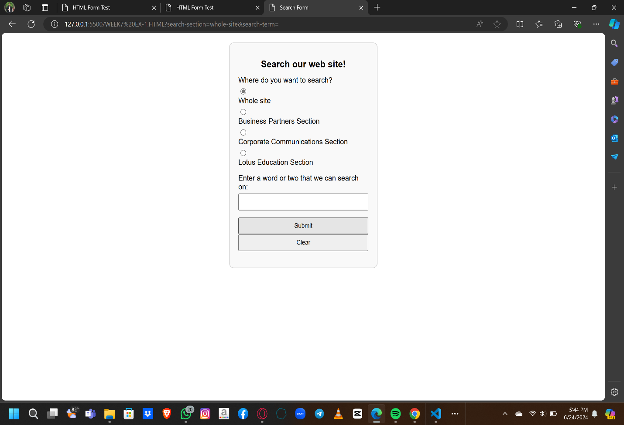

**EXERCISE-2**

Create a new web page and create a Form with following form controls. [ Hint: Make use of TABLE].

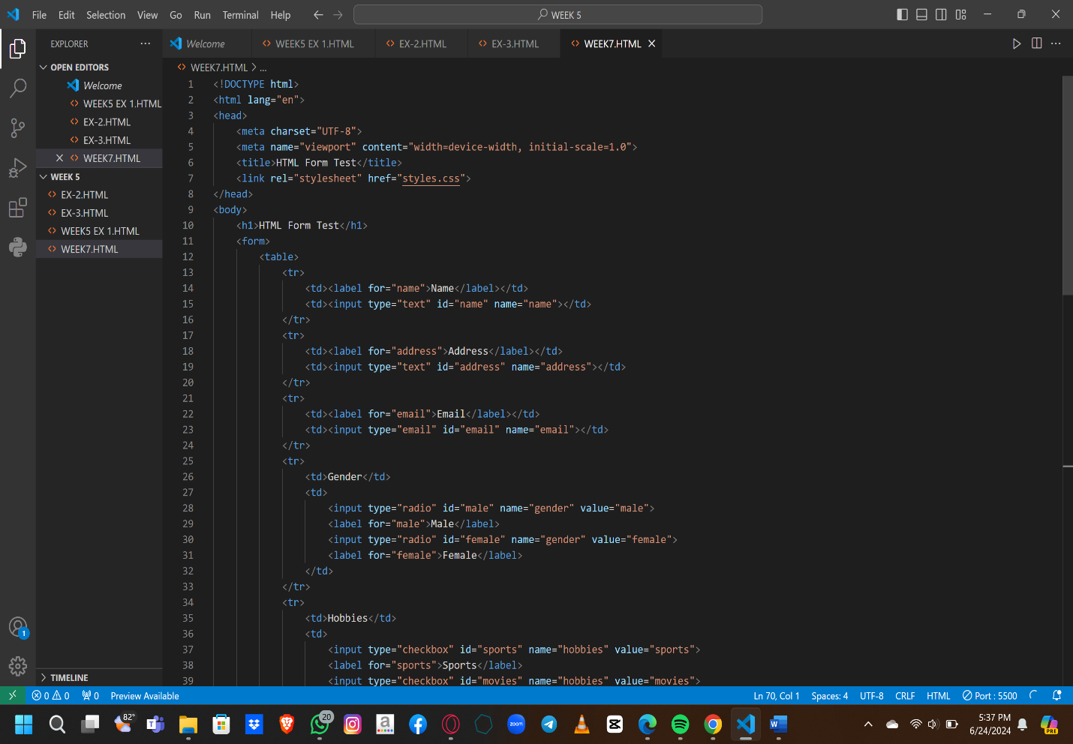

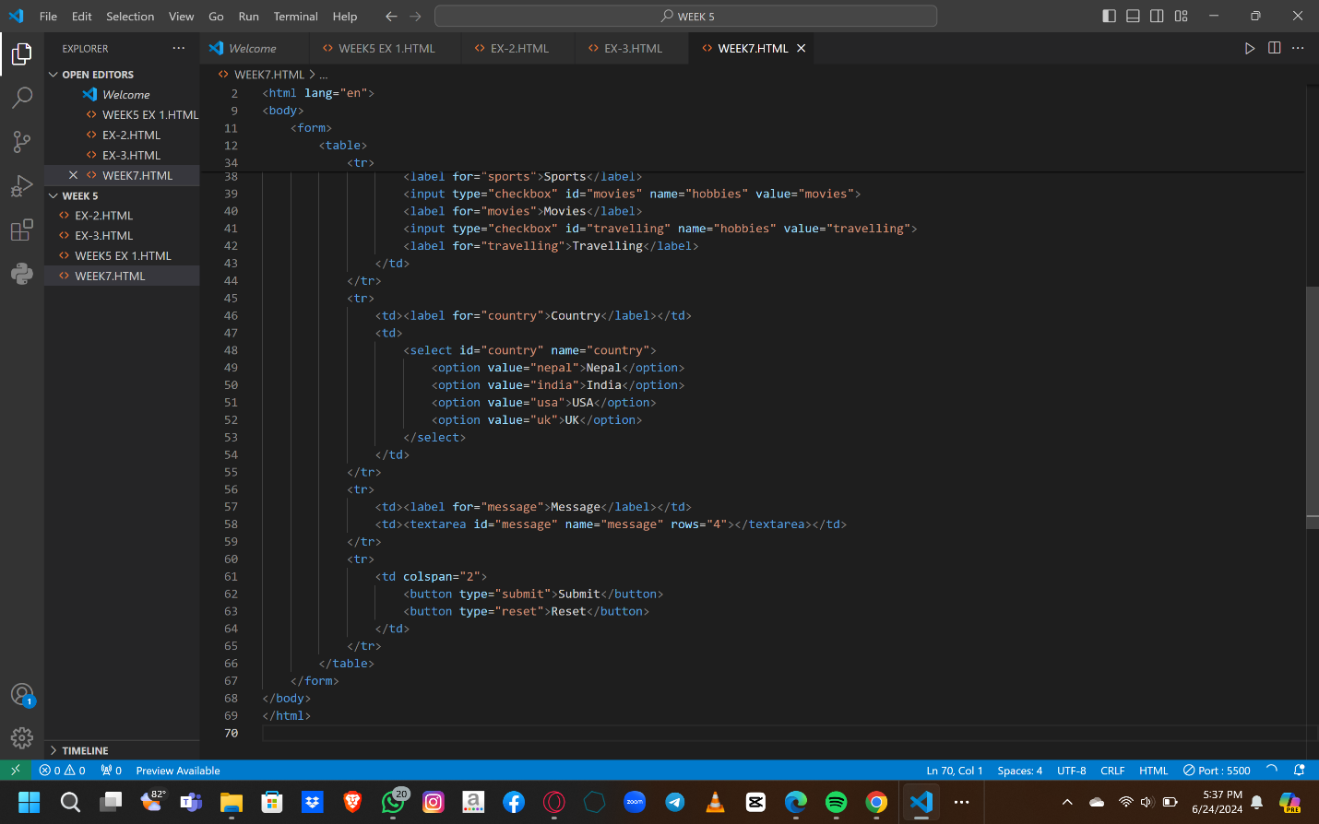

**OUTPUT:**

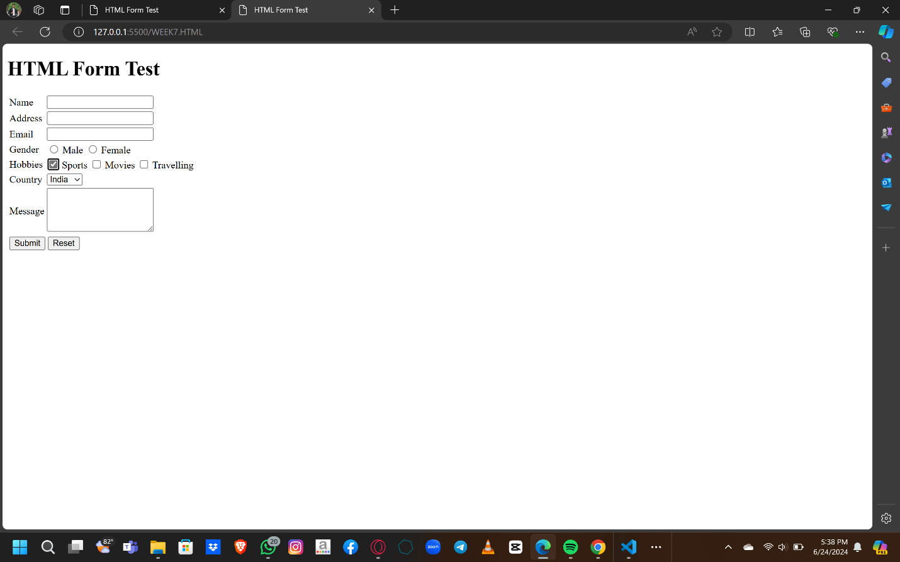

EXERCISE-3

Create a Web page giving the following Bus details. Place a border for the table and use cell padding to present the cell data with clarity. Align the table in the center of the screen. Use a caption saying ‘Bus Sewa Time Table and Fare List

OUTPUT:

